

**HOLLY CLARKE**

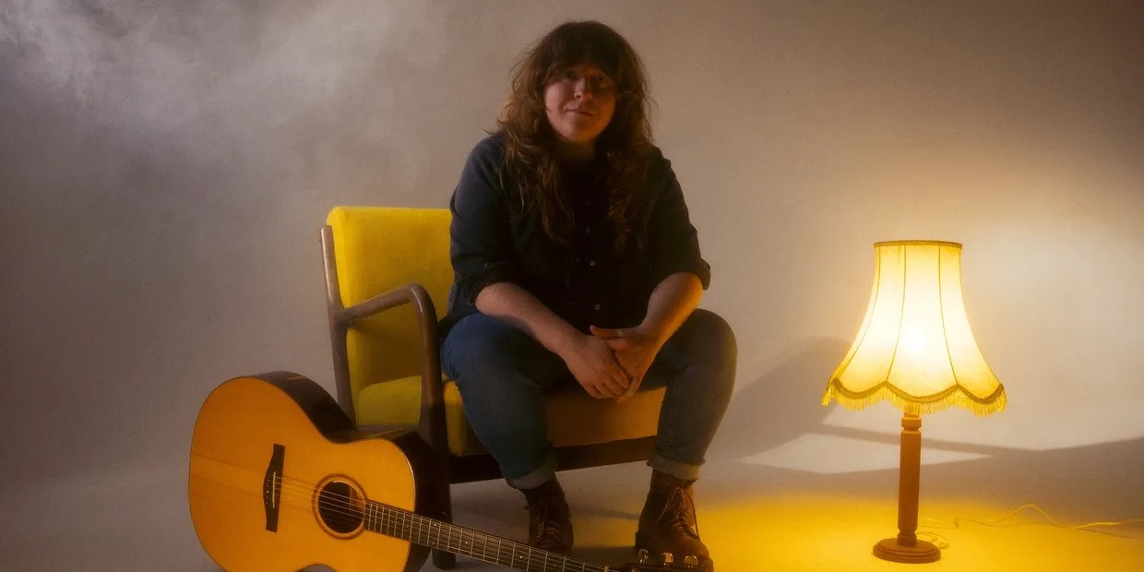

**ACCESS RIDER**

Holly has an ASD (Autism Spectrum Disorder) diagnosis called Semantic Pragmatic Language Disorder. Although this particular diagnosis of SPLD is no longer used, Holly finds it useful as it best describes her particular difficulties.

Holly’s processing of language both spoken and written is one of the primary difficulties that she faces. Although she engaged with a lot of speech therapy to help with her speech and has implemented coping mechanisms, even to this day she still can have some rare moments of difficulty understanding what is being said. So to combat this, if Holly is struggling to fully understand fully what’s being said, she might say “I am not sure quite what you mean” and she will probably need you to speak a bit more straightforward or plainly.

Other than speech, Holly is sensitive to noise. In soundcheck she may have quite an anxious demeanour but her coping mechanism is that she will use ear plugs if she is uncomfortable.

If possible Holly would always appreciate a quiet spot/room where she can escape to, to regulate before a performance or after a long journey.

At some concerts, Holly’s dad Sam will accompany her if a particular trip is logistically quite difficult via public transport; in these cases, a guest/crew pass will be required.

If you need to discuss any of this further please contact Lucy Franklin at Fancourt Music, on +44 7926 978673 or lucy.franklin@fancourtmusic.com.